Tyro Tidings
June 2026 Tyro Christian Church
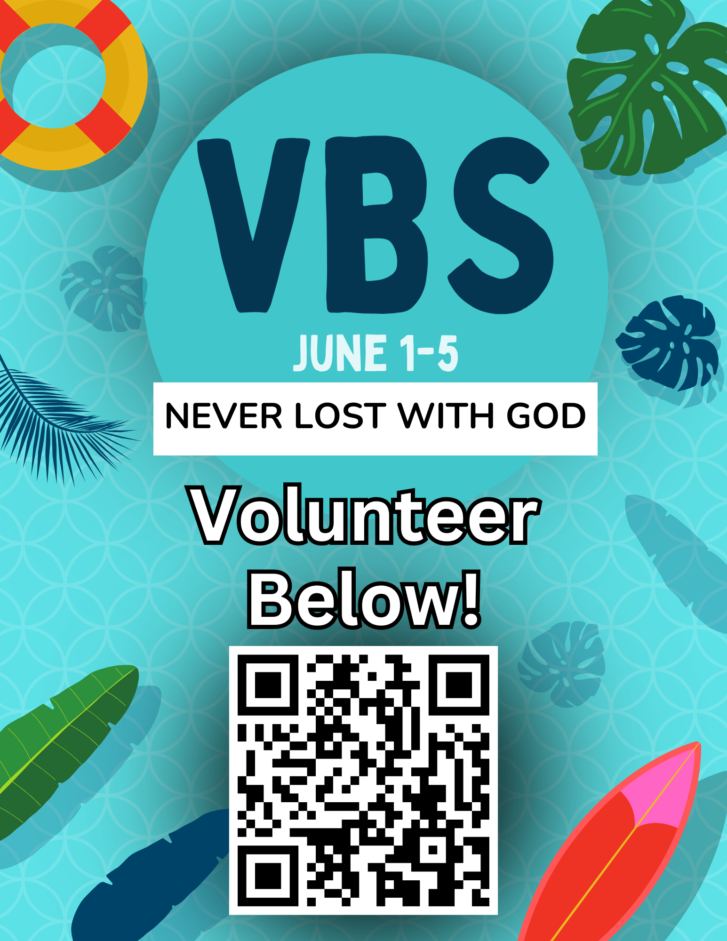

U.S. Postage
PAID
Non-Profit Org.
Permit No. 2
Tyro, KS 67364

Tyro Christian Church,
P.O. Box 307,
Tyro, KS 67364

Return service requested

JUNE 2026 CALENDAR
May 31st Promotion Sunday
June 1-5th VBS 2026
June 7th VBS Celebration at TCC
June 7th-12th Sr. High Camp Cyokamo
June 14th-19th Jr. High Camp Cyokamo
June 19th 1st Grade Day Camp
June 26th Kindergarten Day Camp 8:30 AM – 5 PM
June 28th-Jul 1st 4th-6th Grade Camp
July 6-7th 2nd-3rd Grade Camp Cyokamo
July 6-10th CIY-9th-12th Grade
July 19th Ice Cream Social/Cornhole 5 PM
June 21st Happy Father’s Day
July 21-24th Bible Basketball
July 29th Church Work Night
August 5th Church Work Night
August 19th Kickoff!
September 9th JOY Group 12 PM
September 12th TCC Car Show
September 25th-26th Getaway

*Indicates meets weekly unless otherwise notified


A note from Allan…………….
New Newsletter Format
All good things must come to an end. Well, not all good things. Eternity in the new heavens and new earth will never end! Other than that, yep, they pretty much all have an expiration date. Chocolate cake, your favorite novel, the waning days of summer (or winter if, like me, you really love the Christmas season) … and, alas, our church newsletter in its current iteration. Beginning in August, we will be moving to a quarterly (seasonal) newsletter in a (mostly) digital format. You can still opt in for a printed copy to be mailed to you, if you would like.
There are several good reasons for this change. The first and most important is stewardship. Postage and printing costs have continued to rise. In an effort to more effectively steward the resources God has entrusted us with, we felt this was a prudent decision at this time.
Additionally, the internet has been around for over 40 years now (can you believe that?!). We have all become accustomed to receiving digital communication. The
newsletter in its new quarterly format will be emailed to all church members, as well as posted on the church’s website. Again, you can opt in to have a copy mailed to you if you would prefer. But we would ask you to join us in our stewardship efforts and read the newsletter electronically, if possible.
Finally, the Staff and Elders looked the newsletter over carefully and all agreed that the information it contains can be disseminated to the church on a quarterly basis without upsetting the proverbial apple cart. This includes our “Jobs for Jesus” section, which will initially be expanded to accommodate a quarterly rotation – though some ministry leaders may prefer to schedule volunteers differently moving forward.
The leadership appreciates everyone’s cooperation with this change. We are always looking for more effective ways to carry out our mission here at Tyro Christian Church: Glorify God, Evangelize the Lost, Mature the Saved, and Share the Burdens of the Needy (G.E.M.S.). Like the old adage goes: the message doesn’t change, but the methods do. And they must. I love you all, and I want you to know that the leadership at TCC will remain committed to carrying out our mission as a church!

For His glory,

Allan

Back in April, I asked those who attended Small Groups and Bible Studies, and Sunday School teachers: What’s your favorite verse in the Bible? Here’s what some put as their favorite verse: 18 people put John 3:16, “For God so loved the world that he gave his one and only son, that whoever believes in him might not perish, but have eternal life.” Several put Jeremiah 29:11, “For I know the plans I have for you, declares the Lord, plans for welfare and not for calamity, to give you a hope and a future.”
Another group of people put 1 Peter 5:7, “Casting all your anxiety on him, for he cares for you.” Some put Romans 12:2, “And do not be conformed to the patterns of this world, but be transformed by the renewing of your mind, so that you may prove what the will of God is, that which is good and acceptable and perfect.” What verse do you recall most in your daily life? Do you have a favorite verse that has great meaning in your daily life? Here are other verses people put down back in April: Ephesians 4:28, Romans 6:1, Ephesians 4:3, Jeremiah 33:3, Matthew 6:33, and Matthew 5:16. Many put Psalms 23:1-6, Proverbs 3:4-6, Luke 1:7, Ephesians 5:22, Psalm 46:1, John 3:30, 1 John 1:1-5, Hebrews 12:5-6, Romans 12:17, John 1:12, Psalm 138:8, John 14:6, 2 Timothy 1:7, Psalm 100:1, John 6:33, Matthew 22:37, James 1:2-3, James 1:5-6, Luke 23:43, Psalm 143:8, Psalm 27, Philippians 4:13, Galatians 5:1, Psalms 119:105, and Psalms 119:11.
Allan and Dena Swinson will be starting a new Sunday School Class for new young married people, up to the age of 30s, in room GU-201 upstairs!
We encourage all newly married and young couples to be involved in this class that starts on June 7th! Topics in the class will help them strengthen their marriages. Please invite people you know who are in this area of life!
I hope you will read God’s Word and come up with a key verse for you, or a favorite verse to always encourage you to walk in a manner that pleases God! Make the Summer of 2026 a summer in the Bible!!
Thanks,
Jeff
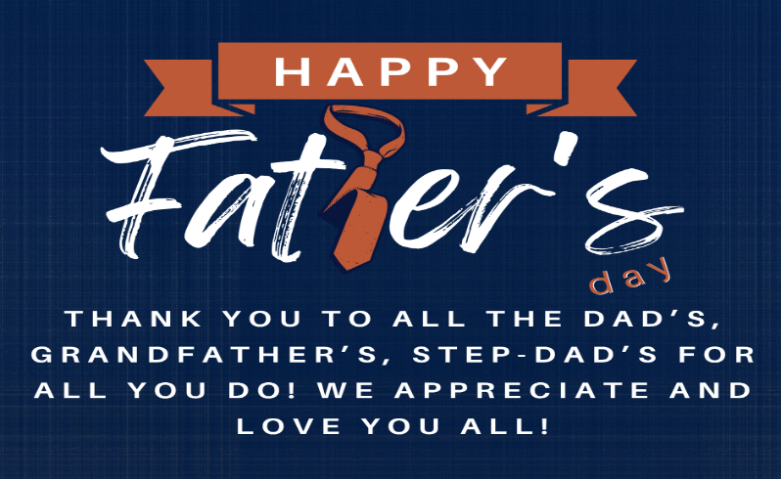

MEN’S BREAKFAST
This month, we’ll be having our Men’s Breakfast on June 13th at 8 AM! If you have any questions or would like to help, contact Kenan Daily.
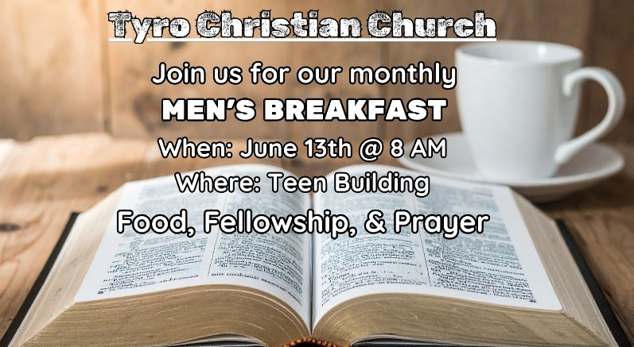

WOMEN’S MINISTRY – HELP NEEDED!!

We’re taking a break for the summer, but we still need your help! We need someone to take over this ministry so we can continue to reach out to the women in our Church!!
TUESDAY LADIES’ BIBLE STUDY
The Tuesday morning Ladies’ Bible Study meets in the Auditorium Kitchen, 9:30-11:00 AM. To stay out of the way during VBS and clean-up from VBS, we will not meet until June 9th.
June 16th to Aug 25th, we will return to our summer study of the minor prophets: Haggai, Zechariah, Malachi & Joel.
We will return to Revelation on September 1st. We will study passages from Genesis to Jude to gain more understanding of the book as we go through it one more time.


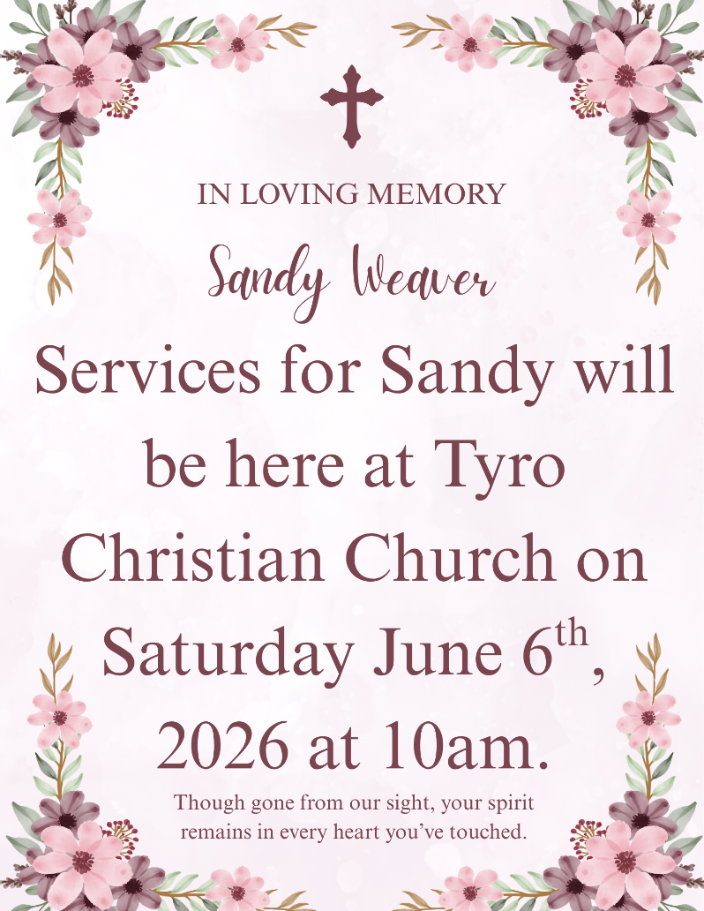

FURNITURE MINISTRY
Robert Cooper needs quality used furniture such as beds, couches, small kitchen tables, appliances, stoves, and fridges for the Longfellow Center! If you or someone you know has the ability to donate something, please reach out!!

BABY BOTTLES
The Midwest Pregnancy Care Centers (Coffeyville and Independence) are having their annual Baby Bottle Campaign at TCC, and bottles were available beginning on Mother’s Day. Bottles are taken home and filled with loose change through Father's Day, then returned to the nursery check-in area at Church. This is a simple and valuable method of supporting this ministry to young women and babies in our towns. All bottles need to be returned by June 21st, please!
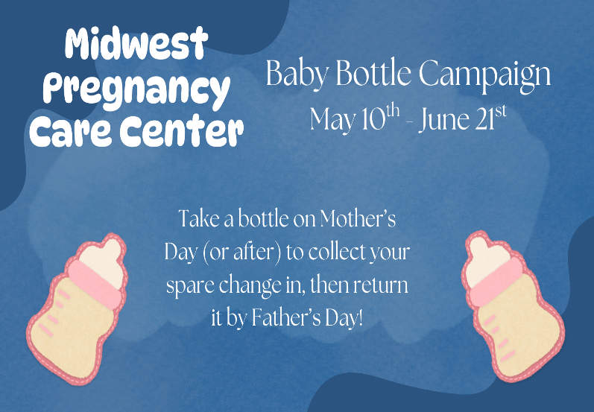

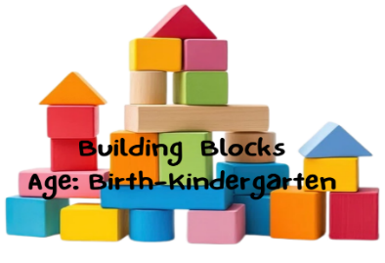

HAPPY Father’s Day—June 21st
Promotion Sunday – May 31st – What an exciting time for the children. The current Kindergarten class of 2026 is now officially 1st graders, and now we have a NEW Kindergarten Class!! An exciting time for them, a milestone for us. These kids are growing up way too fast!

Jr VBS – June 1st-5th – This year, VBS will be a wonderful time for the children to learn about “Letting our Light Shine for Jesus”. Jr. VBS is for 4-year old’s and those going into Kindergarten. The time is 9:00 AM to 12:00 PM. This is a fun event for children to experience God’s great love and to learn Bible stories, sing fun songs, and have fun making crafts.
We will ask all nursery workers (babies through 3s) to be here by 8:00 AM. The workers will be able to make it to their designated spot to be with the children and help them get to the right place that they need to be.

Sunday, June 7th, is our VBS celebration. We will have a luncheon, and then the parents will be able to walk through the church and to see where their child was during VBS. This is a great time for us to introduce ourselves to the parents and invite them to come the following Sunday. Please come and visit with everyone. If you are interested in helping in any way, please contact Zac Gulick or Joyce Foster.

Day Camp for those going into Kindergarten will be on Friday, June 26th. “Fruit of the Spirit” is our theme. The information and registration form are located just inside the nursery doors. This is for the children who will be going into Kindergarten in the Fall of 2026.
We have been learning the " Fruit of the Spirit” song during our Worship time over the last several years. We will learn how to put it into practice on this fun-filled day. We will start here in the Building Block (preschool building), doing lessons, singing, crafts, and games. We will have a surprise activity for them to show “Fruit of the Spirit” and then an outing to a surprise location (Independence Kiddy Park and ice cream following from Dairy Queen). We will be back at the Church for more lessons, crafts, and food! The time will be from 8:30 AM to 5:00 PM on Friday, June 26th. Mom and Dad, if you are interested in helping, please let Joyce Foster know at 620-779-2702.


2026 UPCOMING EVENTS
June 1–5 — VBS
June 7—After Church VBS Celebration
Camp Cyokamo
June 19 — 1st Grade
June 28–July 1 — 4th–6th Grade
July 6–7 — 2nd–3rd Grade
July 21–24 — Bible Basketball
Aug 19 — Wednesday Night Kickoff
Sep 30 — See You at the Pole
Oct 4 — Hayrack Ride
Oct 25 — Trunk or Treat


RESOURCES: Our church’s website offers a variety of resources for families, including access to the Sunday curriculum and other valuable parenting tools. Be sure to check out the available links for guidance and support! If you’re interested in serving, head over to the Tyro Christian Children’s Ministry Facebook page or scan the QR code to get connected!


CAMP CYOKAMO This year at Camp Cyokamo, our theme is The Wilderness Project, focusing on how God uses wilderness moments to grow our faith and teach us to trust Him. Students can sign up today at tyrochristian.org or by scanning the QR code, where you can also find more information. We can’t wait for camp this summer!


VBS: VBS runs June 1–5 from 9:00 AM to noon and is open to kids ages 4 through those entering 6th grade! Each day is packed with fun, engaging activities, meaningful Bible lessons, games, and opportunities for kids to grow in their faith and build friendships. For transportation details, check out our Facebook page to see available bus stops, or sign your kids up today by scanning the QR code. We can’t wait to see your family there!

VBS CELEBRATION: This year, we’re excited to host our VBS Celebration on June 7th right here at the church immediately following service! We’ll have a free meal, games, and plenty of fun for the whole family. It’s a great opportunity for families to spend time together, check out the Faith Factory, and experience all that’s happening here at the church in a relaxed and welcoming environment. We’re looking forward to celebrating an incredible week of VBS together!

BIBLE BASKETBALL CAMP:

July 21–24, this basketball camp will feature a fun, high-energy environment filled with skill drills, scrimmages, and competitions led by local athletes and coaches. Our goal is to help students grow not only in their basketball skills but also in their relationship with God through encouragement, mentorship, and community. Sign up at the QR code.



Hello, parents and friends of Tyro Teens!
It’s the summer!
Wednesday nights for the school year of ’25-’26 have run their course. I write that sentence with incredible sadness. We covered a lot of ground this last school year. We saw growth. We had fun. We saw fellowship. We saw worship. We saw service. We encountered Jesus. We are looking forward to the summer and to next year as we welcome new 7th graders!

VBS

If you are a teen and you haven’t yet signed up to volunteer for VBS, I would absolutely encourage you to stop everything you are doing and sign up right now! Follow this QR code:

This Summer
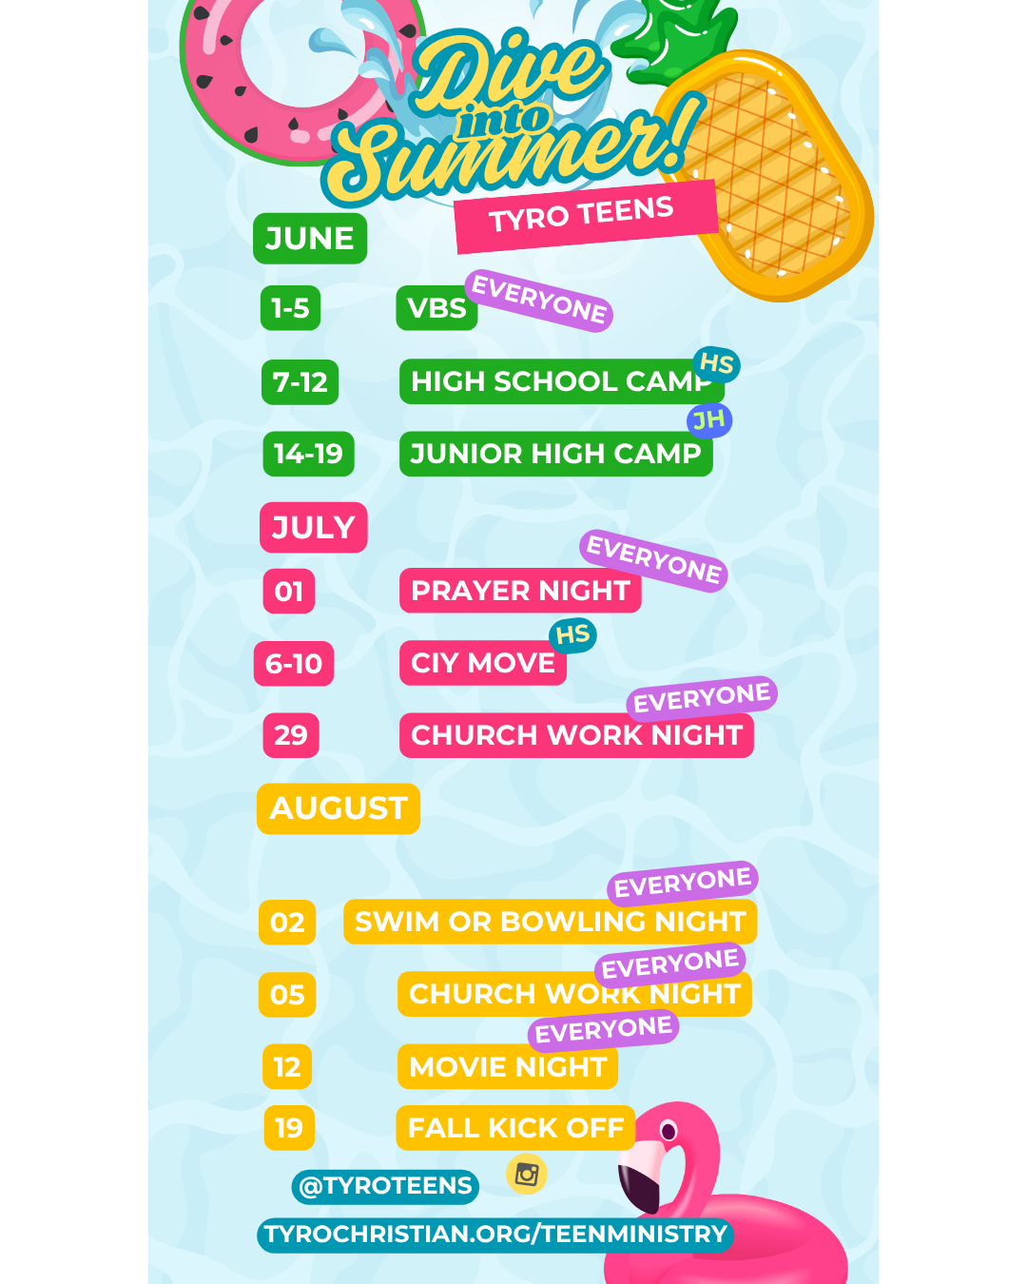
We’ve got a lot of stuff going on this summer, not limited to camps and CIY: check out the graphic below for a schedule:

PRESCHOOL JUNE BIRTHDAYS
02 Carter Harrington 20 Valley Buck
09 Addie Deal 21 Liam Wilson
13 Norah Scott


1st-6th GRADE JUNE BIRTHDAYS
12 Keirland Steele 12 Luke Brant

TEEN JUNE BIRTHDAYS
01 Michael Moore 17 Ella Jabben
05 Charly Daily 25 Joey Wheatley
12 Julia Heady 25 Alaina McClure

15 Khloe Kudrick 26 Carter Scott

YOUNG ADULT JUNE BIRTHDAYS
08 Mattie McDaniel 26 Cole Brake
08 Ashtyn O’Kane 26 Violet Robins
09 Elizabeth Moore 27 Heidi Keene
13 Ace Koester 29 Abby Cunningham
13 Stephanie Smith 30 Jayci Hayward
26 Colt Hightower 30 Emery Keene

HAPPY BIRTHDAY TO ALL

TCC JOY NEWS
Hey JOY Groupers!
SEE YOU IN THE FALL!!
Last month was our last lunch until September! We look forward to seeing you all after the summer!

NOTICE:
Back in the 70s, Nancy Allen’s mom, Wanda Lindesmith, started the Senior Saints, which later became known as JOY Group. She served for many years before handing it over to Nancy. She has served for nearly 40 years, with help from Gloria White and Cheryle Jabben. 19 years ago, Ron Winsor volunteered to drive the bus and help as much as needed. We are extremely grateful for their combined services to the JOY Group!
However, Nancy Allen and Ron Winsor are stepping away from serving the JOY Group. That said, we have several others who have been more than willing to step up to the plate! But we are looking for someone with a CDL to drive the bus, so if you or anyone you know would be willing to serve, contact the Church office!

MISSISSIPPI RIVER CRUISE ITINERARY
Tyro Christian Church JOY Group Jul 27- Aug 1st
Itinerary:
Monday, July 27 (L, D)
§ Travel to St. Joseph, MO
§ Welcome lunch in St. Joseph
§ Tour the Pony Express Museum, Pony School & Patee House
§ Overnight stay at the Drury Inn & Suites
§ Dinner at the Frederick Inn
Tuesday, July 28 (B, L, D)
§ Breakfast at the hotel
§ Travel to Hannibal, MO
§ Lunch at Becky Thatcher’s Cafe
§ Trolley Tour of Hannibal, Mark Twain Boyhood Home &
Museum
§ Overnight at the Best Western Riverfront
§ Dinner Cruise on the Mark Twain Riverboat
Wednesday, July 29 (B, D)
§ Breakfast at the hotel
§ Visit the John Deere Pavilion
§ Lunch (on own) and shopping in Downtown Moline
§ Tour the Buffalo Bill Museum
§ Overnight at the Hyatt Place East Moline
§ Dinner at the Hyatt
Thursday, July 30 (B, L, D)
§ Breakfast at the hotel
§ Full Two-Day Cruise on the Upper Mississippi to include all
meals & snacks onboard the Riverboat Twilight, overnighting in
Dubuque, IA
§ Overnight in Dubuque
Friday, July 31 (B, L, D)
§ Return Cruise (full day) to include all meals & snacks onboard
the Twilight
§ Overnight at the Hyatt Place East Moline

Saturday, August 1 (B, L)
§ Breakfast at the hotel
§ Lunch at the Machine Shed
§ Return home with many great memories to share with friends,
old & new alike
Inclusions: 5 nights lodging, 15 meals (5 breakfasts, 5 lunches, 5 dinners), all admissions & sightseeing as listed, luggage handling at the hotels, all taxes & meal gratuities.
Policy & Pricing: Based on a minimum of 40 paid persons:
Sgl: $1879 Dbl: $1589 Tpl: $1469

Enjoy thoughts by Gloria from past JOY Group Newsletters…
“Whatever you dislike in another person, take care to correct yourself.” – Thomas Sprat

“Why do you look at the speck of sawdust in your brother’s eye and pay no attention to the plank in your own eye?” – Matthew 7:3

WOMEN’S QUILTING CLASS
AND BLANKET BLESSINGS:
Hey, ladies! Our last meeting was last month, and now, we will break for the summer and come back in the Fall! Quilters can work on their projects, and the Blanket Blessings ladies can work on those projects; there is always plenty to do. Ladies, we look forward to seeing you in the Fall!! If you have any questions, contact Denise Theiss at 620-205-9533!

June Birthdays
05 Mindy Browning 17 Madison Mays
06 WeEtta Cranor 17 Patty Young
09 Alina Heater 22 Kendra Grant
10 Don Elliott 27 Denise Theiss
10 Tara Parker 27 Robert Cooper
10 Don Perkins 30 Karen Jabben
16 Sheila Cliff 30 Robyn Daniels

HAPPY BIRTHDAY TO ALL!

June Anniversaries
3 Don & Cheri Elliott
3 Danny & Norma Scott
4 Keith & Karin Wright
7 Keith & Barbara Porritt
10 David & Jan Taylor
14 Stan & Carol Eli
16 Millard & Ethel Landis
21 Dave & Toni Thomas
30 Fred & Anna Marie Brown

HAPPY ANNIVERSARY TO ALL!

