Tyro Tidings
July 2026 Tyro Christian Church
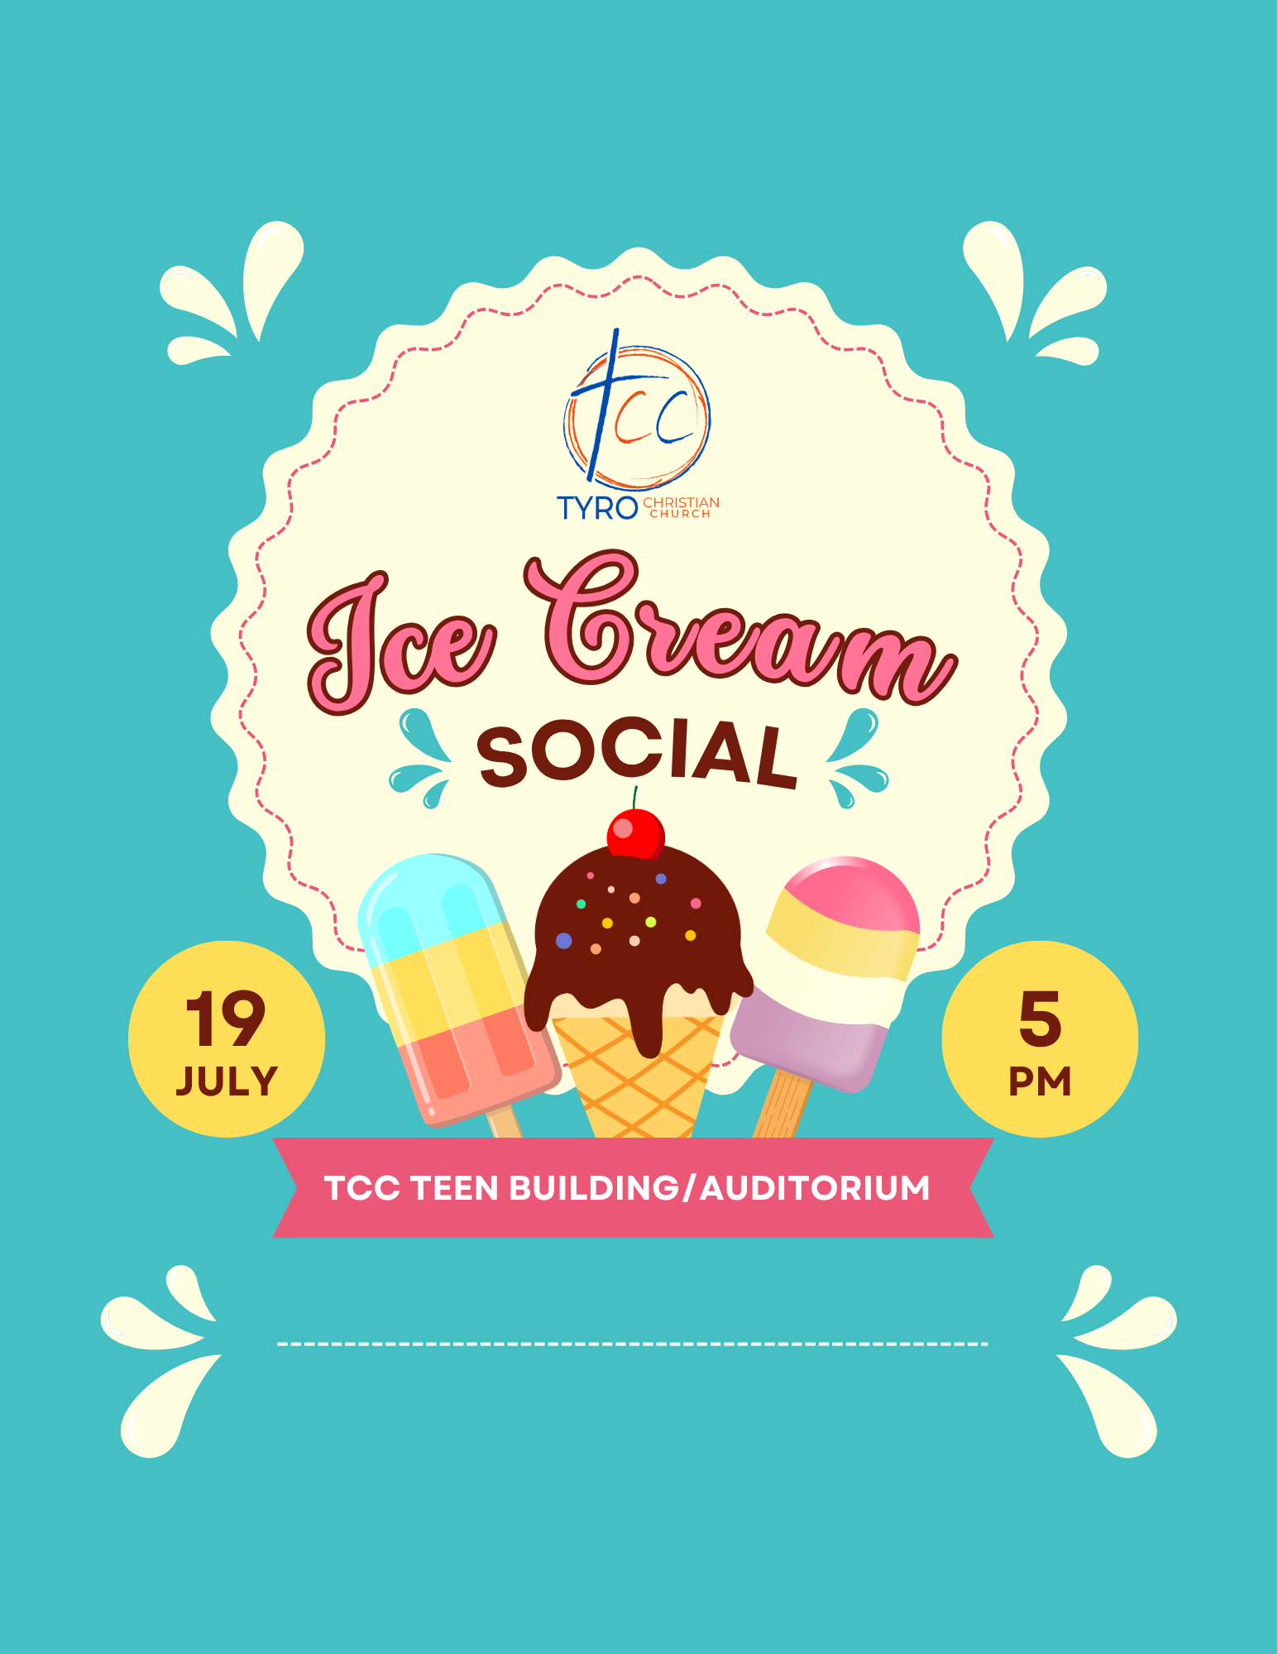

U.S. Postage
PAID
Non-Profit Org.
Permit No. 2
Tyro, KS 67364

Tyro Christian Church,
P.O. Box 307,
Tyro, KS 67364

Return service requested

JULY 2026 CALENDAR

June 28th-Jul 1st 4th-6th Grade Camp
July 6-7th 2nd-3rd Grade Camp Cyokamo
*July 7th Tuesday Morning Ladies’ Bible Study 9:30 AM
July 6-10th CIY-9th-12th Grade
July 12th Birthday come and go for Patty Cron 2p Happy 95th!
July 19th Ice Cream Social/Cornhole 5 PM
July 21-24th Bible Basketball 6-8p
July 27th-Aug 4th JOY group trip Mississippi River Cruis
July 29th Church Work Night 6p
August 2nd Teen swim night
August 5th Church Work Night 6p
August 8th Men’s Breakfast 8 AM
August 19th Wednesday Night Kickoff!
September 2nd Adult small groups kickoff for Fall
September 7th Offices Closed
September 9th JOY Group Cookout 12 PM
September 12th TCC Car Show
September 25th-26th Jr. High Getaway
September 30th See you at the Pole
October 4th Hayrack Ride
October 10th Men’s Breakfast 8 AM
October 14th JOY Group Lunch 12 PM
October 25th Trunk or Treat

*Indicates meets weekly unless otherwise notified

A note from Allan…………….

Life, Liberty, and the Pursuit of Holiness

On July 4, 1776, the newly formed United States adopted the Declaration of Independence, proclaiming our sovereignty as a nation and our independence from
Great Britain. On July 4, 2026, America celebrates her 250th birthday—the semiquincentennial (thank you, internet). One of the most well-known and beloved lines from America’s founding document is the first sentence of the second paragraph: “We hold these truths to be self-evident, that all men are created equal, that they are endowed by their Creator with certain unalienable Rights, that among these are Life, Liberty and the pursuit of Happiness.”
I love those words. They are timeless. They are powerful. They are and were revolutionary. And while I wouldn’t go so far as to say the Founding Fathers got it “wrong,” I get hung up on the word “happiness.” I get it. I want to be happy. I want my family to be happy. I want you to be happy. And I’m sure you’ve heard the phrase, “God cares more about your holiness than your happiness.” There may be some truth to that, but that doesn’t mean that God wants us to be unhappy.
My concern is that America has become obsessed with happiness while being very unconcerned with holiness. I don’t believe that was the intent of the Founding Fathers. In his farewell address in 1796, George Washington said, “Of all the dispositions and habits which lead to political prosperity, Religion and morality are indispensable supports.” In a letter to Thomas Jefferson dated June 28, 1813, John Adams wrote, “The general principles on which the fathers achieved independence were the general principles of Christianity.” Though not a Founding Father, in 1837, John Quincy Adams wrote, “The highest glory of the American Revolution was this: it connected in one indissoluble bond the principles of civil government with the principles of Christianity.” At least in principle, America’s founders believed our happiness was directly linked to our holiness.
Much like the Declaration of Independence signaled a new beginning for a new people, in Matthew 5–7 Jesus preached a sermon that launched a movement. He begins with what we now call the Beatitudes, or the list of “Blessed are…” Blessed, in Hebrew thought, was much like our word “happy.” Jesus declared that blessedness (happiness) would be found by those who are pure in heart, who make peace, who are meek, and those who hunger and thirst for righteousness. In other words, those who pursue holiness.
On America’s Big Birthday this year, many Americans will celebrate. Many of them will pursue happiness without pursuing holiness. Let us never forget that the two are inseparable. This was true in the minds of those who founded our great nation. This was true in the teaching of Jesus. And it is true for those who bear His Name.
For His glory, Allan



On Wednesday, July 29th, we will be doing a service project at 1411 South Elm St. in Coffeyville, Kansas, with Friend and Kin Properties Inc. We will have a sign-up sheet in the Foyer on Sunday, July 5th! Robert and Linda Cooper will have a list of projects and what will need to be brought for these projects! We will have supper from 5:45-6:00 PM, then we will start working from 6:00 until 8:00. Please sign up in the Foyer to help with this project!
I’m looking to start a Bible Study in Room A-104 from September 2nd through November 18th! Then on Wednesday Night, December 2nd, will be our Banquet in the Church Gym for all our Small Groups and Bible Studies! In the month of August, starting August 2nd and going until August 16th, we will have a sign-up for Small Group and Bible Study leaders, people to open up their homes, and those who would like to attend a Small Group or Bible Study.
On Wednesday, August 19th, we will have a meeting for all who are leading a Small Group or Bible Study in Room A-104 from 7:00 to 8:00 PM.
I hope everyone will be involved in learning and growing in God’s Word this coming Fall!

Thanks,
Jeff
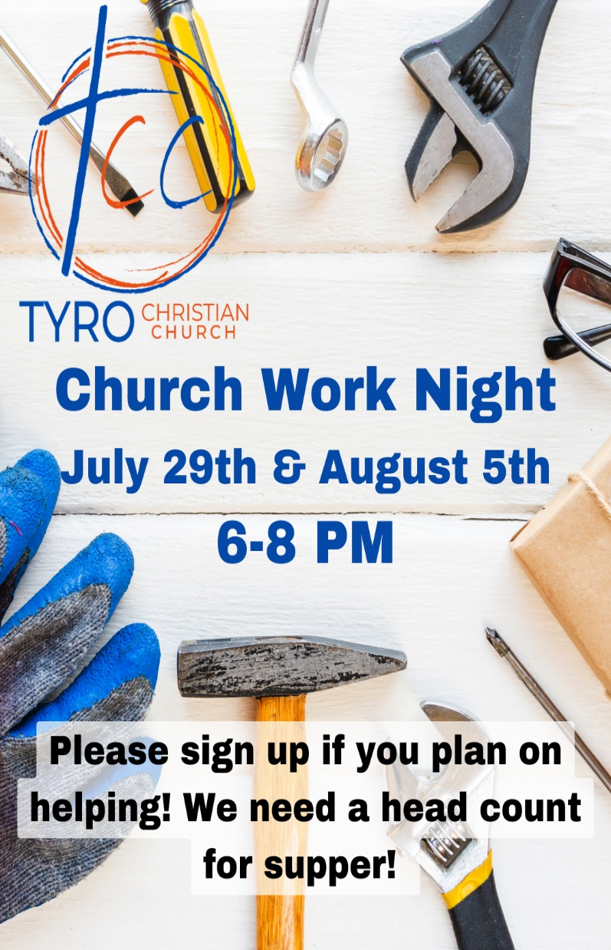

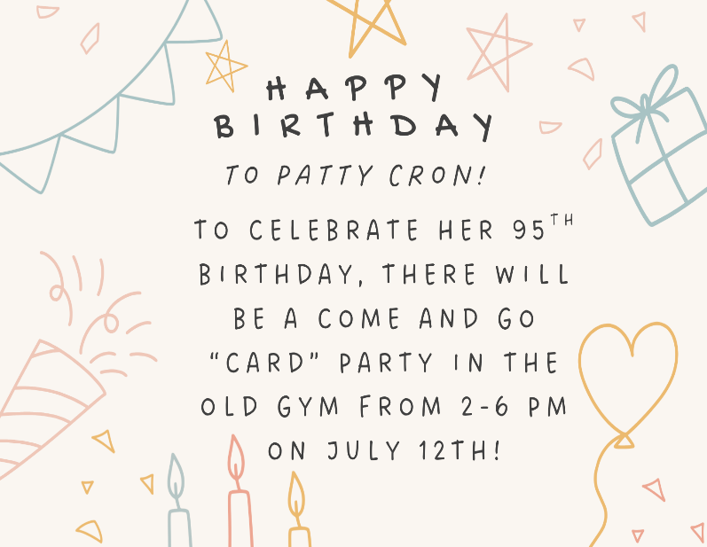
MEN’S BREAKFAST
This month, we’ll be having our Men’s Breakfast on July 11th at 8 AM! If you have any questions or would like to help, contact Kenan Daily.
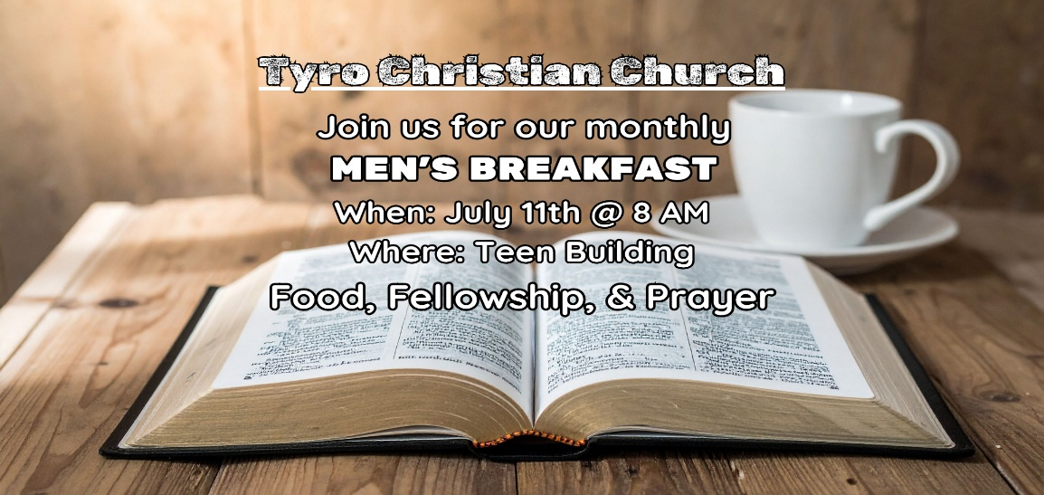

WOMEN’S MINISTRY – HELP NEEDED!!
We’re taking a break for the summer, but we still need your help! We need someone to take over this ministry so we can continue to reach out to the women in our Church!!


TUESDAY LADIES’ BIBLE STUDY
The Tuesday morning Ladies’ Bible Study meets in the Auditorium Kitchen, 9:30-11:00 AM! July 7th to Aug 25th, we will be in our summer study of the minor prophets: Haggai, Zechariah, Malachi & Joel. We will return to Revelation on September 1st. We will study passages from Genesis to Jude to gain more understanding of the book as we go through it one more time.

FURNITURE MINISTRY
Robert Cooper needs quality used furniture such as beds, couches, small kitchen tables, appliances, stoves, and fridges for the Longfellow Center! If you or someone you know can donate something, please reach out!! They will also need to be delivered to the Longfellow Center in Coffeyville!

NEWSLETTER CHANGES
Just a reminder, this month is the last time we will print an all-paper newsletter, and it’s the last monthly newsletter. Beginning next month, we will transition to a digital, quarterly newsletter that will be posted on our website, tyrochristian.org. If you still want a printed copy, please sign up in the Foyer!

THANK YOU!!
We want to say a huge THANK YOU to Frank Hull for bushhogging the old softball fields for us! It’s much appreciated!!

COLLEGE MOVE-IN DAY
This year, College Move-In Day is on August 15th. We will begin collecting donations on July 12th. This year, we have chosen to focus on bringing in a certain item in contrast to previous years, when we have had a list. So, this year, we are asking that you bring in laundry pods.

ICE CREAM SOCIAL
We are having our annual Ice Cream Social and Cornhole Tournament on Sunday, July 19th, in the Teen Building! This year, we’re doing it a little differently. First, we’re providing hotdogs and chips for dinner in addition to the ice cream. As far as the ice cream goes, if you sign up to bring some, we need to know how much (1 gal, 2 gal, etc.) and what kind. Since we’re also providing dinner, we really need to know how many are planning on coming! So please sign up at the table in the foyer, whether you’re bringing ice cream or toppings (such as chocolate sauce, sprinkles, etc.), playing cornhole, or just coming to enjoy fellowship with other believers. Even if you sign up for the cornhole tournament or to bring ice cream, please also sign up on the list that asks for a headcount, so we have a full list of how many people are going to attend. We’ll also be having worship and a short devotion after the cornhole tournament in the Main Auditorium, so please stick around for that!

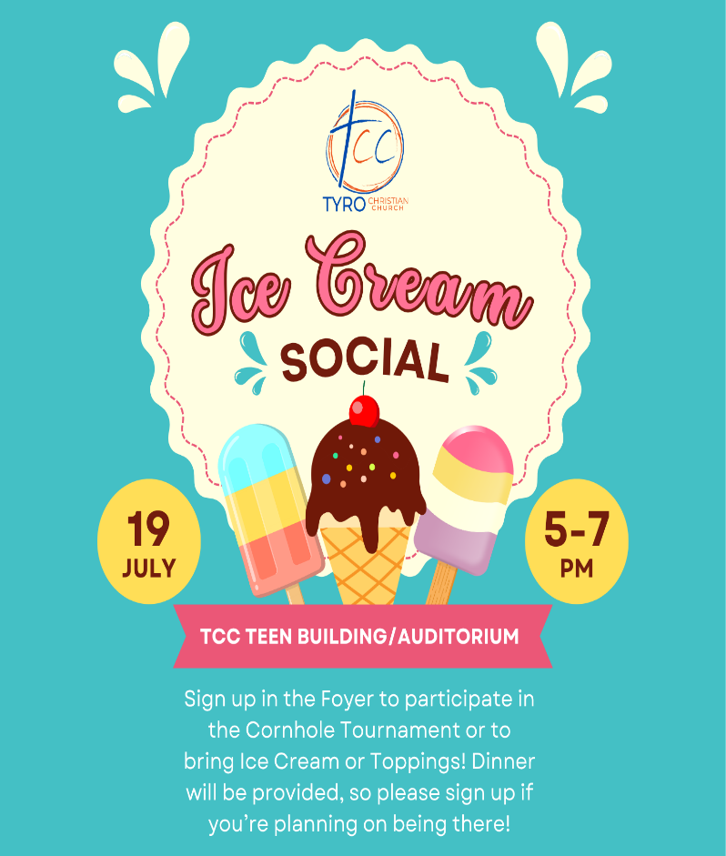



Jr VBS– We had a fantastic week! We average 31 in the nursery / Jr. VBS area. This includes babies through Kindergartners. The kids had fun with the lessons and making crafts. The rain came, and we survived! It was a great week for all of us! It is exciting to see children learn the Word of God and memorize it! I just want to say a big THANK YOU to all volunteers who helped in the nursery area, check-in, security, and in the Jr. VBS area. We couldn’t do it without all your help. Carolyn Daily did a fantastic job with the crafts, along with Doug Hanlon with the lessons! It was an amazing year.
We will be getting ready for next year's Jr. VBS! It is never too early to start praying for this ministry. Anyone who may be interested in helping with Jr. VBS, please contact Joyce Foster.


Day Camp – June 26th - We had a packed, fin-filled day! We had lessons and crafts with some interesting games. Then for lunch, we went to Independence Kiddie Park and Zoo. Since we were so close, we had to visit Dairy Queen for our dessert. Then back to the church for lessons, crafts, and games. I’m not sure about the kiddos, but I know I was tired. Thank you to all of the helpers: Wayne and Linda Moon, Tammy Peffley, Phoebe Datson, Sharon and Lex Ward, and Mike Foster. Kindergarten Day Camp could not be without volunteers!

Fall Program - It is hard to believe that summer is halfway over, and school will start soon. More information concerning our Fall Kick-off in August will be coming. We will have Wednesday nights starting with supper at 6:30 PM and ending at 8:00 PM. We will be studying Ephesians 6, starting off with Children obey your parents and ending it with the Armor of God.




2026 UPCOMING EVENTS
July 6–7 — 2nd–3rd Grade
July 21–24 — Bible Basketball
Aug 19 — Wednesday Night Kickoff
Sep 30 — See You at the Pole
Oct 4 — Hayrack Ride
Oct 25 — Trunk or Treat

RESOURCES: Our church’s website offers a variety of resources for families, including access to the Sunday curriculum and other valuable parenting tools. Be sure to check out the available links for guidance and support!

CAMP CYOKAMO This year at Camp Cyokamo, our theme is The Wilderness Project, focusing on how God uses wilderness moments to grow our faith and teach us to trust Him. Students can sign up today at tyrochristian.org or by scanning the QR code, where you can also find more information. We can’t wait for camp this summer!

VBS APPRECIATION: Thank you to everyone who helped make VBS such an incredible week! Whether you served in front of students or behind the scenes, your time, energy, and willingness to serve made a lasting impact. Because of you, hundreds of kids had the opportunity to learn about Jesus, build friendships, and experience God's love in a fun and meaningful way. VBS truly takes the whole church working together, and I am so grateful for each of you. Thank you for investing in the next generation and for helping make this week a success!

BIBLE BASKETBALL CAMP:

Join us July 21–24 from 6:00–8:00 PM for Basketball Camp! Open to students entering 3rd–6th grade, this fun-filled camp will feature skill development, games, scrimmages, and competitions led by local athletes and coaches. Our goal is to help students grow in their basketball abilities while also encouraging them in their faith through mentorship, community, and learning about God. Sign up at the QR code.



Hello, parents and friends of Tyro Teens!
We are, as is usual this time of year, on location at Cyokamo Christian Camp. It is squarely in the middle of a two-week stretch at camp with teenagers, first with Senior High students, and now with Junior High Students. One of the things that I love about camp is that we get to hang out with the kids and have real conversations with them without the pressure of time being such a burden. We’re here, in the middle of nowhere, Missouri, and there are scheduled downtime portions of the day where we get to have free time with the students. The conversations that come out of those moments can sometimes be more profitable than the conversations we have after a message because they are so unstructured, and because everyone has their guards down.
It’s always been interesting to me how the Holy Spirit moves. Who’s to say that the next great revival won’t originate with Junior High students at a small camp in the middle of nowhere, Missouri? MAY GOD BE PRAISED!!!!

CIY
Parents, if you haven’t already gotten your forms filled out, please follow the links below. One will take you to a video that will tell you how to fill out the form, and the other is the form itself.




Be sure to get these forms filled out!

CIY Worship Night
Everyone is invited to join us for a worship night in the Teen Building on July 1st. This will be an opportunity to pray over our students and over the things they will be encountering while we are in Lincoln. Please take some time to join us as we sing, pray, and have fellowship with those students and adults going to Nebraska July 6th-10th.

PRESCHOOL JULY BIRTHDAYS
07 Chancee Dupuis 21 Myles Foster
12 Molly Clark 26 Kaislee Dougherty
16 Kyler Reed 28 Jessi Snelson
18 Beau Brake 28 Charli Brake

18 Josie Snelson 31 Poppy Buck

1st-6th GRADE JULY BIRTHDAYS
03 David Barton 15 Christopher LaForte
03 Hudson Heater 15 Nova Ward
03 Harper Cranor 20 Jayden Brant
03 Jaxson Cranor 24 Ava Fitzsimmons
08 Sable Oliver 25 Ezekias Betts
10 Sirinity Foster 31 Addy Pyle

TEEN JULY BIRTHDAYS
04 Molleigh Kaminska 09 Barak Eden
08 Callie Furnas 16 Bryleigh Rigdon
08 Jaylyn Cotton 29 Olivia Chiartano


YOUNG ADULT JULY BIRTHDAYS
05 Heide Blackert 28 Kolbi Wheat
20 Taylor Allen 28 Audra Heady

HAPPY BIRTHDAY TO ALL!

TCC JOY NEWS
Hey JOY Groupers!
SEE YOU IN THE FALL!!
Our May lunch was our last lunch until September! We look forward to seeing you all after the summer!

MISSISSIPPI RIVER CRUISE ITINERARY
Tyro Christian Church JOY Group Jul 27- Aug 1st
Itinerary:
Monday, July 27 (L, D)
§ Travel to St. Joseph, MO
§ Welcome lunch in St. Joseph
§ Tour the Pony Express Museum, Pony School & Patee House
§ Overnight stay at the Drury Inn & Suites
§ Dinner at the Frederick Inn
Tuesday, July 28 (B, L, D)
§ Breakfast at the hotel
§ Travel to Hannibal, MO
§ Lunch at Becky Thatcher’s Cafe
§ Trolley Tour of Hannibal, Mark Twain Boyhood Home &
Museum
§ Overnight at the Best Western Riverfront
§ Dinner Cruise on the Mark Twain Riverboat
Wednesday, July 29 (B, D)
§ Breakfast at the hotel
§ Visit the John Deere Pavilion
§ Lunch (on own) and shopping in Downtown Moline
§ Tour the Buffalo Bill Museum
§ Overnight at the Hyatt Place East Moline
§ Dinner at the Hyatt
Thursday, July 30 (B, L, D)
§ Breakfast at the hotel
§ Full Two-Day Cruise on the Upper Mississippi to include all
meals & snacks onboard the Riverboat Twilight, overnighting in
Dubuque, IA
§ Overnight in Dubuque
Friday, July 31 (B, L, D)
§ Return Cruise (full day) to include all meals & snacks onboard
the Twilight
§ Overnight at the Hyatt Place East Moline

Saturday, August 1 (B, L)
§ Breakfast at the hotel
§ Lunch at the Machine Shed
§ Return home with many great memories to share with friends,
old & new alike
Inclusions: 5 nights lodging, 15 meals (5 breakfasts, 5 lunches, 5 dinners), all admissions & sightseeing as listed, luggage handling at the hotels, all taxes & meal gratuities.
Policy & Pricing: Based on a minimum of 40 paid persons:
Sgl: $1879 Dbl: $1589 Tpl: $1469

Enjoy thoughts by Gloria from past JOY Group Newsletters…

“Whatever you dislike in another person, take care to correct yourself.” – Thomas Sprat

“Why do you look at the speck of sawdust in your brother’s eye and pay no attention to the plank in your own eye?” – Matthew 7:3

WOMEN’S QUILTING CLASS
AND BLANKET BLESSINGS:
Hey, ladies! Our last meeting was last month, and now, we will break for the summer and come back in the Fall! Quilters can work on their projects, and the Blanket Blessings ladies can work on those projects; there is always plenty to do. Ladies, we look forward to seeing you in the Fall!! If you have any questions, contact Denise Theiss at 620-205-9533!

July Birthdays
02 Darren Brake 15 Patty Cron
04 Tim Rice 16 Kylee Stallsmith
04 Mark Grant 20 Debbie Wright
05 Chrissy Nunneley 21 Becky Lemos
06 David Olson 25 Van Ward
06 Pat George-Knox 25 Tammy Rodgers
07 Sharon Ward 27 Helen Johnson
08 Cara Gulick 28 Gina Kelley
12 Aaron Robins

HAPPY BIRTHDAY TO ALL!

July Anniversaries
16 Sid & Virginia Haffener
24 Perry & Allison Daily
27 Mike & Brenda Frye
27 Terry & Pam Frye

HAPPY ANNIVERSARY TO ALL!



